**International University of Business Agriculture and Technology**

**Lab report 07**

Name       : Abdullah Md Jahid Hassan.

Student ID: 20203020

Course     : CSC 440

Section     : A

Semister   : Fall 2022

Sl no     :

Mobile no : +8801756254873

E-mail       : hassan20203020@gmail.com



**Submitted to**

Rashedul Islam

Senior lecturer

Date: 09-11-2022

**Board 01**

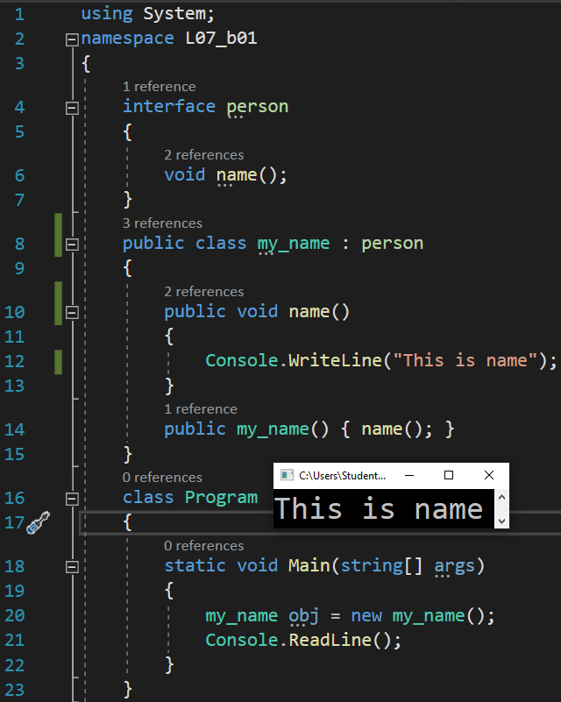

**Board 02**

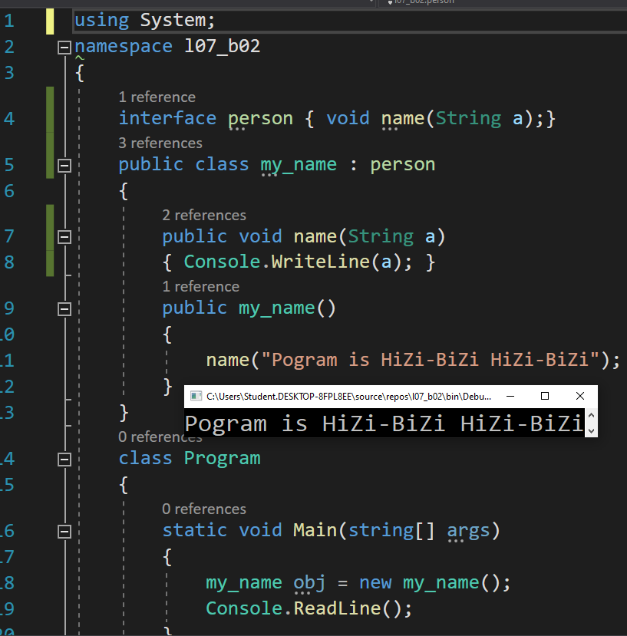

**Board 03**

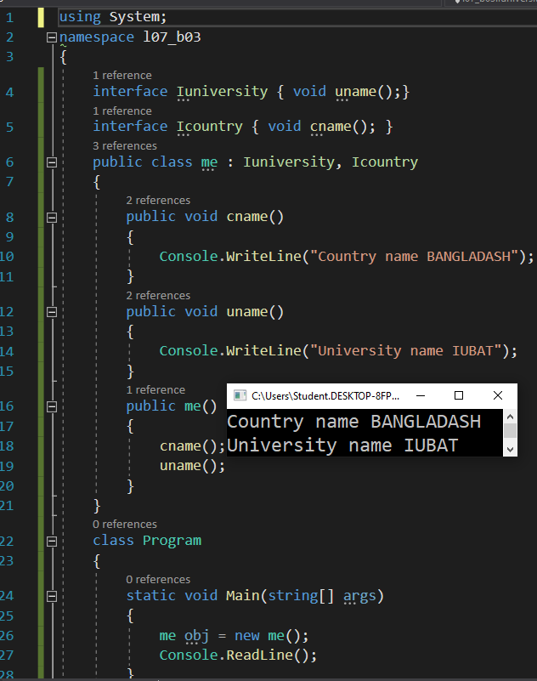

**Board 04**

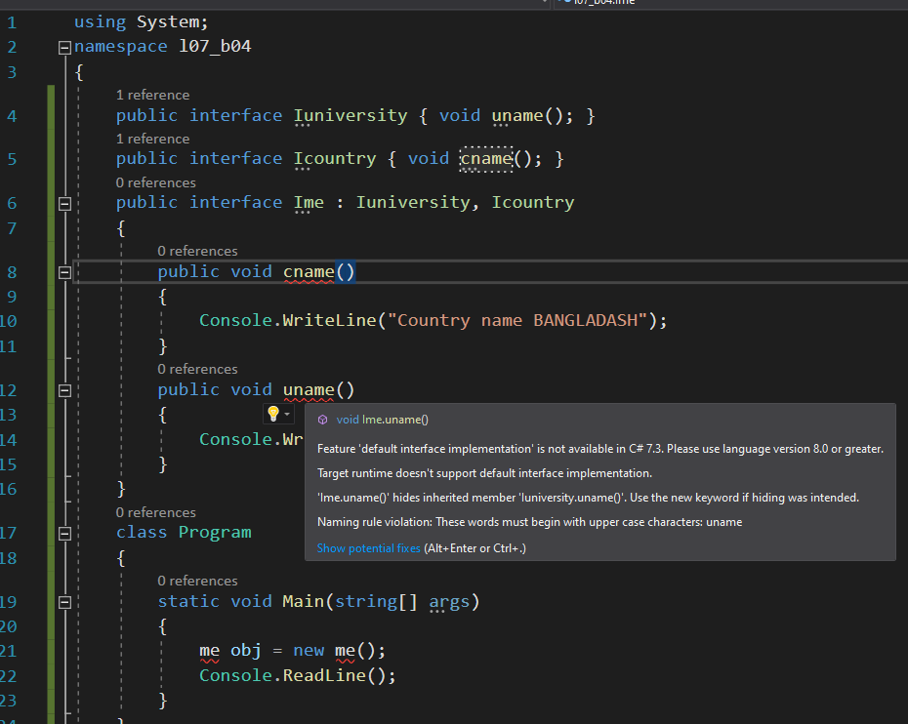

**Board 05**

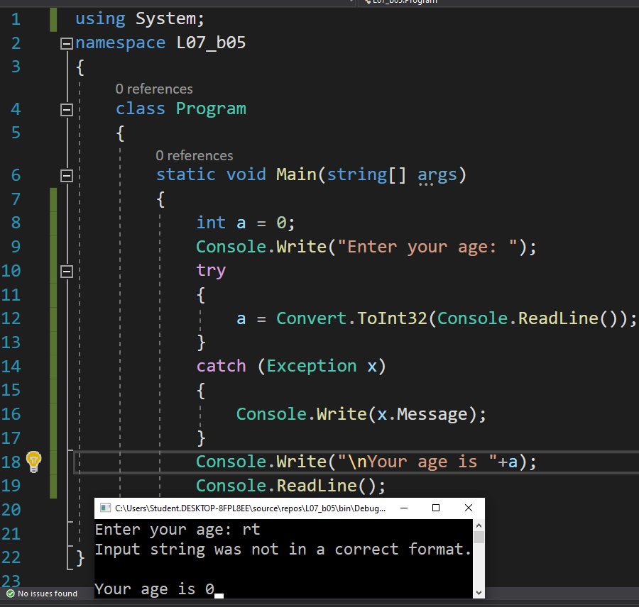

**Board 06**

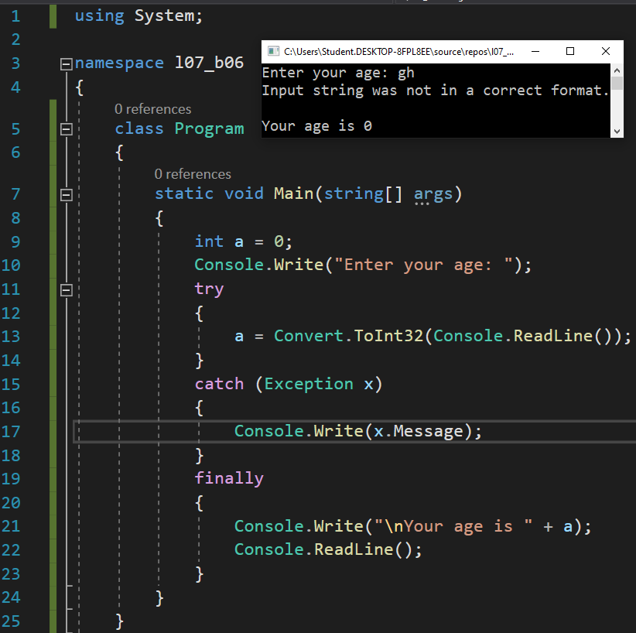

**Board 07**

